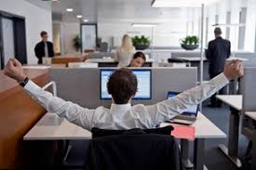
Environment
- Indoors
- Work that requires you to be indoors most of the time
- Outdoors
- Work that requires you to be outdoors most of the time
- One main location or site
- Different locations or sites
- Clean
- I don’t mind getting dirty
- I don’t mind working in dust
- I don’t mind noise
Travel time
- No travel
- Travel between sites
- Travel between towns
- Overseas travel
Work Hour
- Regular day time work
- Shift work
- Irregular hours
- Sessional work
- Long hours of work
- Evening work
- Weekend work
- On call
- Flexible hours
- Other pattern (fly in-fly out)
- Working from home

Physical Requirements
- Sitting
- Standing
- Working at Heights
- Climbing ladders, scaffolds, elevated platforms, etc
- Walking or running
- Kneeling, Crouching or Crawling
- Lifting
- Using Hands
- Bending
- Making Repetitive Motions
- Common Protective or Safety Attire
- Equipment such as safety shoes, glasses, gloves, hearing protection, hard hats or life jackets?
- Specialised Protective or Safety Attire
- Equipment such as breathing apparatus, safety harness, full protection suits or radiation protection?

